SMART FARMING SYSTEM

N SAI JAGADEESH (RA1911029010075) P V S S POOJITH (RA1911029010098)

PROBLEM STATEMENT:-

In this project I have made a working prototype model, using home gateway, sensor, relay module and motor, the programming is done on cisco packetTracer. All the system is integrated in such a way that it monitors water levels as wellThe water in soil (or) field is sensed by sensor node and the sensed data is sent to microcontroller node through wireless networking .the limits we set in sensor as it works when the water level is less than 5

In comparisons after monitoring for alternate 4 days in traditional way and smart irrigation we analysed the reduction of water wastage was nearly 33% compared to traditional way

SOFTWARE REQUIRED :-

Packet Tracer is a cross-platform visual simulation tool designed by Cisco Systems that allows users to create network topologies and imitate modern computer networksCloud website: the cloud website which is used is Thing Speak. The farmer can see all the data updates on this site, by just clicking the channel link. Details can be seen on

HARDWARE USED :-

1)HOME GATEWAY - The cisco packet tracer interface provides inbuilt devices to be added in the network. The first step is to select home gateway device from the network devices. To authenticate and validate the wireless connection, we also can configure home gateway with WEP/WPA-PSK /WPA2 protocols2)Water level monitor - Used to detect water level of home environment3)Lawn sprinkler - Used to sprinkler based on water level of the environment

PROCEDURE:-

We need to select the number of sprinklers according to the area.

We need to select water level monitor as well according to sprinklers.

Now connect all to the home gateway,set password to the homegateway.

Convert all the devices into homegateway server.

Now connect to the cell phone and configure to th homegateway.

Give the logical stuff for to operate the sprinklers(here I gave , if water level is less than 5 it will on if it is greater than 5 it will off)

Like this we did the smart farming system.

CIRCUIT DIAGRAMS:-

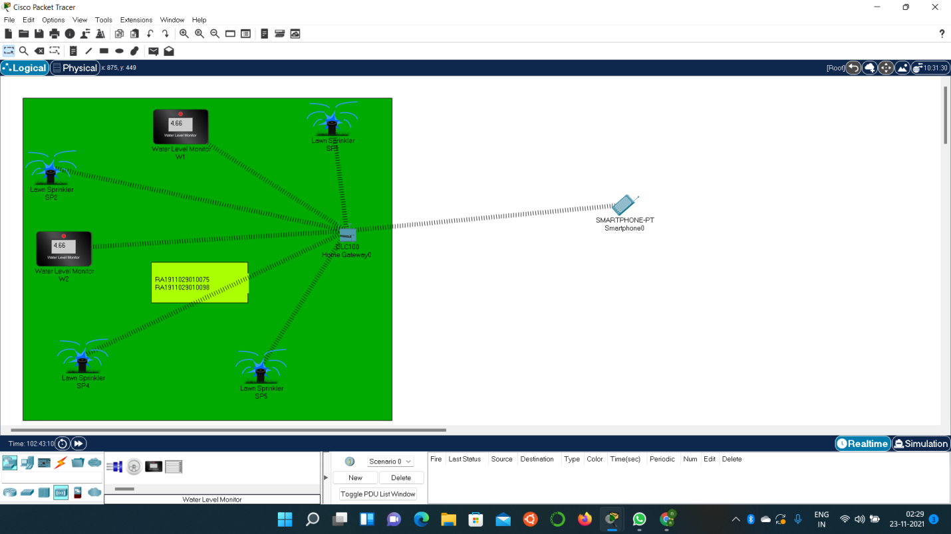

CONFIGURATION:-

IN HOME GATEWAY-

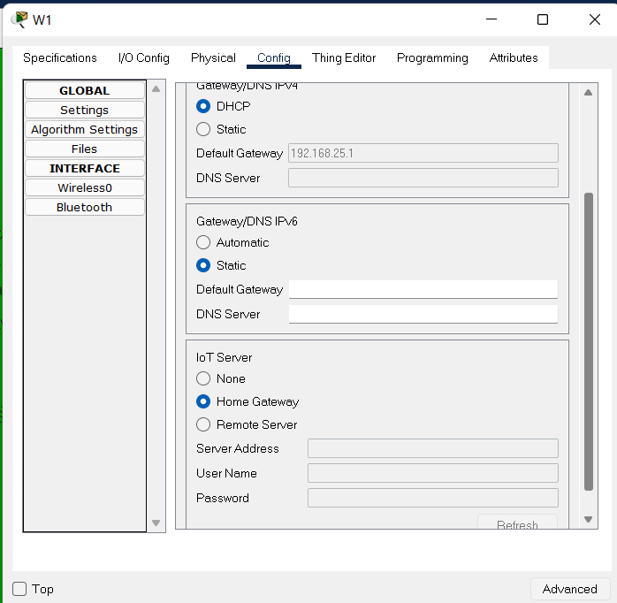

IN PHONE-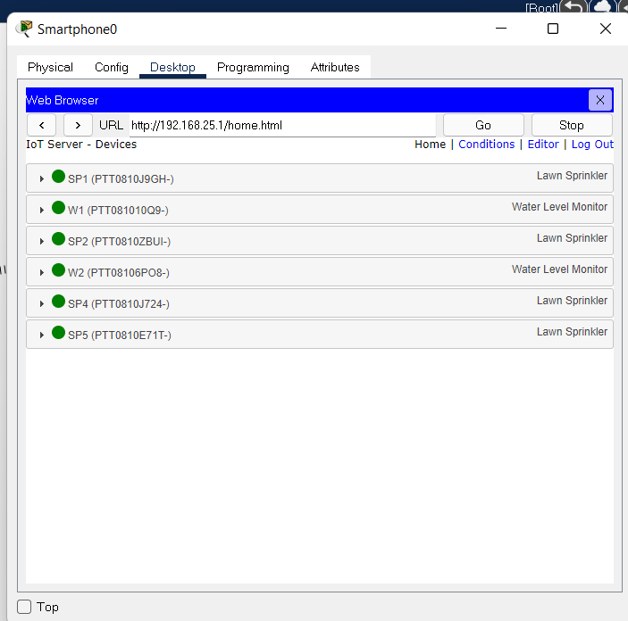

RESULTS:- The sprinkler was successfully was done and we got the required output

OUTPUT:-

When sprinkler is on



When sprinkler is off

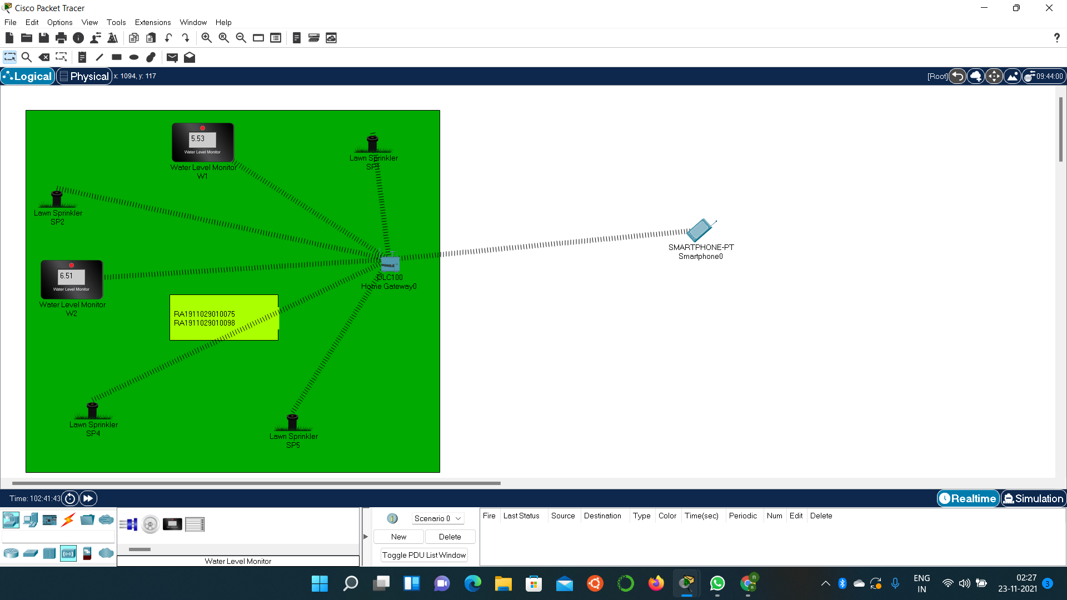

CONCLUSION:-

In this paper, I implemented smart home using new released cisco packet, because this version included different IOE device used for home automation. I used home Gateway to register smart device on it to control them and Microcontroller (MCU) to interconnect different sensor and IOE device. Also MCU provide programming environment to manage different device, differentprogramming language available on MCU but I used JavaScript and python to control the device

REFERENCE :-

[1] Chattoraj, Subhankar. "Smart Home Automation based on different sensors and Arduino as the master controller." International Journal of Scientific and Research Publications5.10 (2015): 1-4.

[2] Soliman, Moataz, et al. "Smart home: Integrating internet of things with web services and cloud computing." Cloud Computing Technology and Science (CloudCom), 2013 IEEE 5th International Conference on. Vol. 2. IEEE, 2013.

[3] S. Haller S. Karnouskos and C. Schroth "The Internet of Things in an Enterprise Context " in Future Internet-FIS